Phase 5 – Project Development
Script-Controlled ACL – Restrict Record Access Based on Field Value
1. User Creation
A test user was created in ServiceNow.
User ID: EEE User
First Name: EEE
Last Name: User
Email: eeeuser@gmail.com
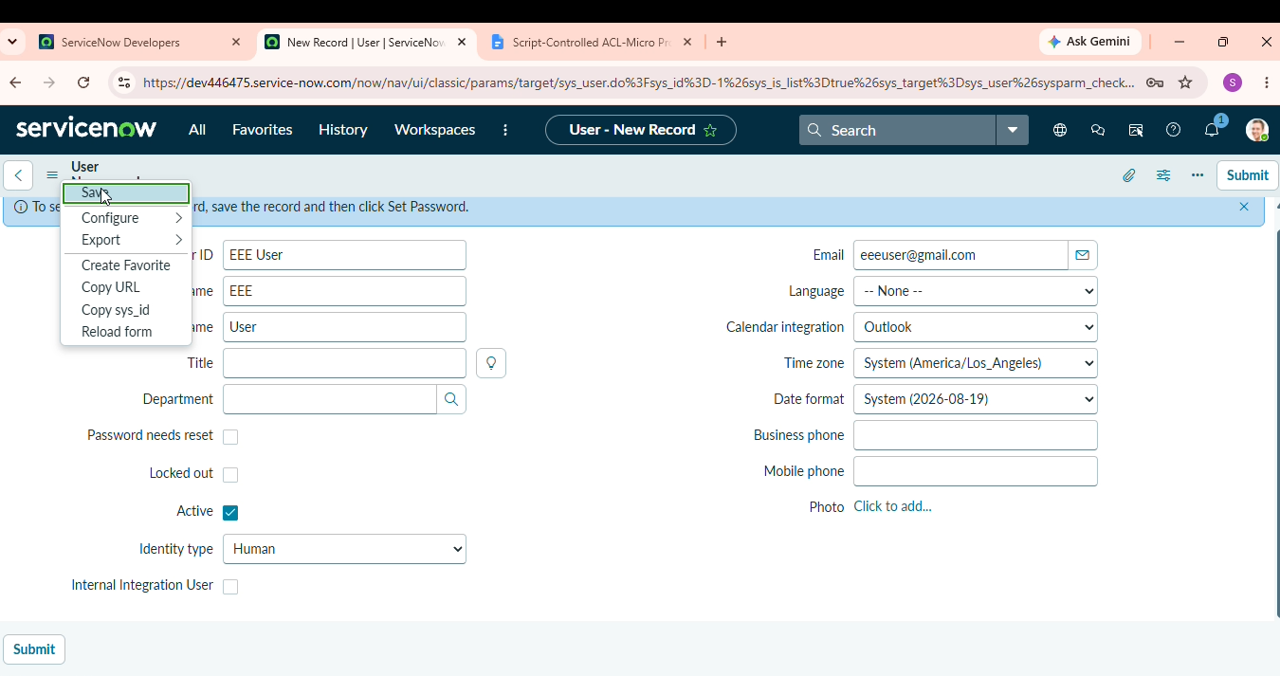
2. Role Creation
The following custom roles were created:
- bb1
- bb2
- bb3
- bb4
All the roles were assigned to the EEE User.
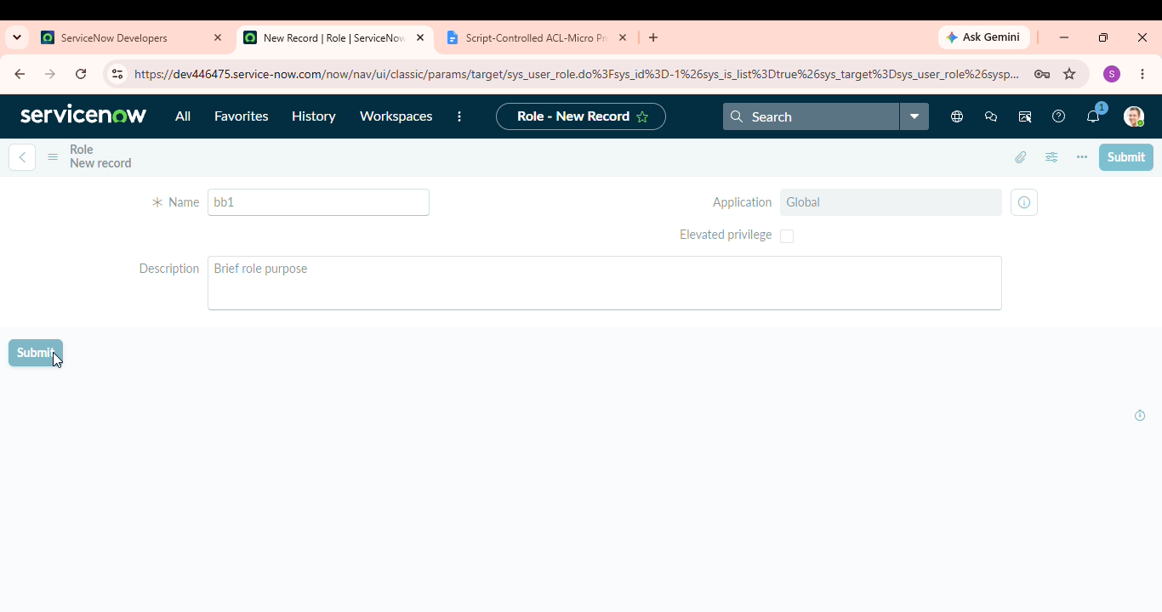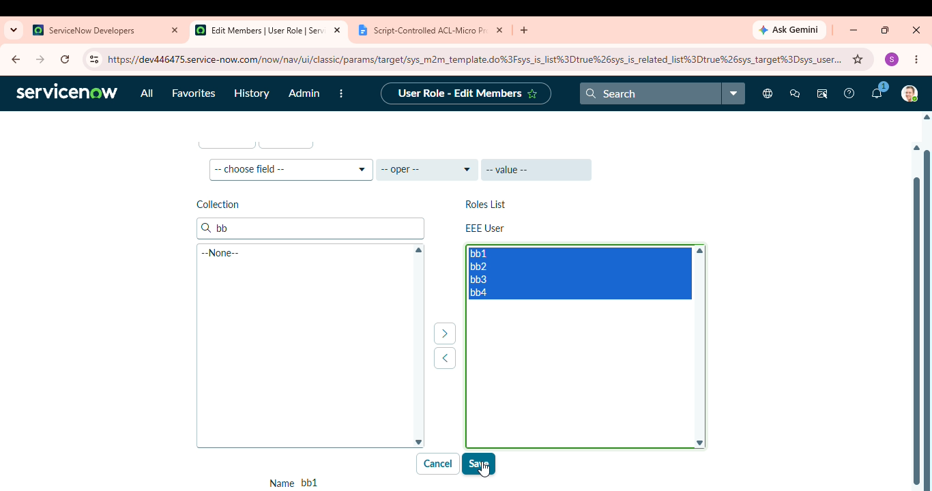
3. Table Creation
A custom table was created.
Label: Institution Details
Name: u_institution_details
Extends for: false

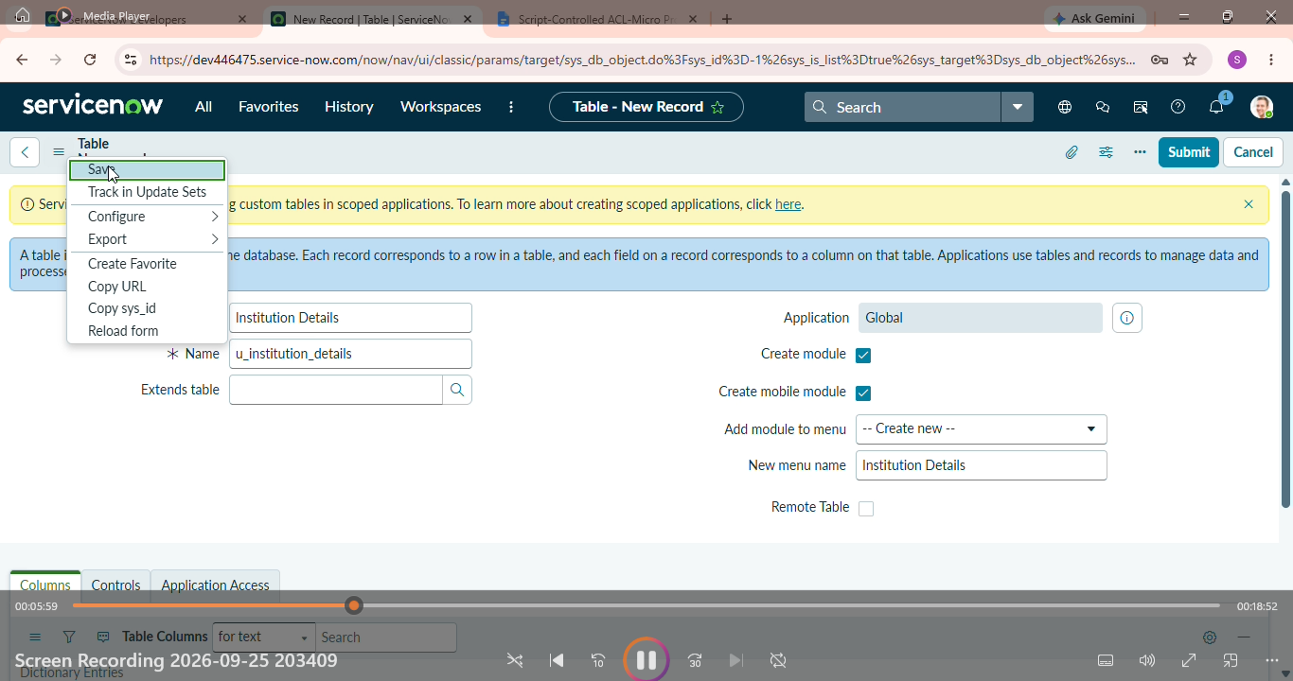
4. Fields Created
The following fields were added:
- Student Roll Number – Auto Number
- Student Name – Reference - User
- Faculty Name – Reference - User
- Branch – Choice
- Email – String
- Phone Number – String
- Description – Multi String
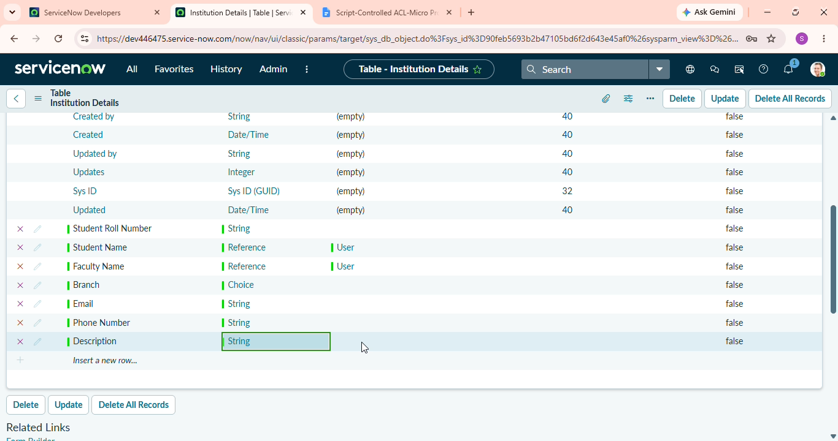
The Branch choices are:
- ECE
- EEE
- CSE
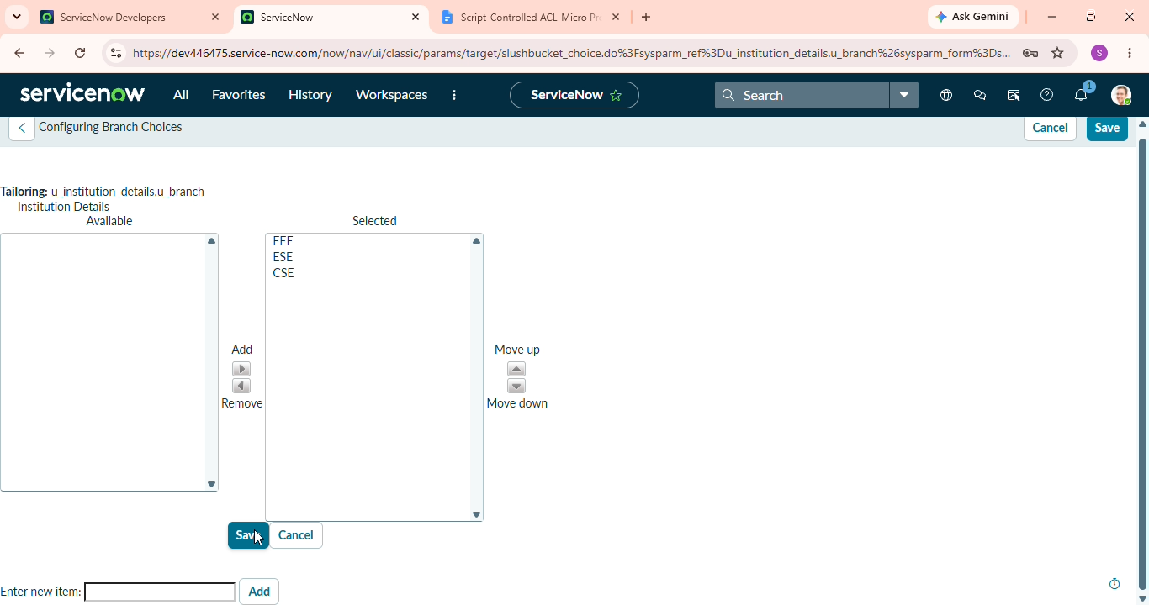
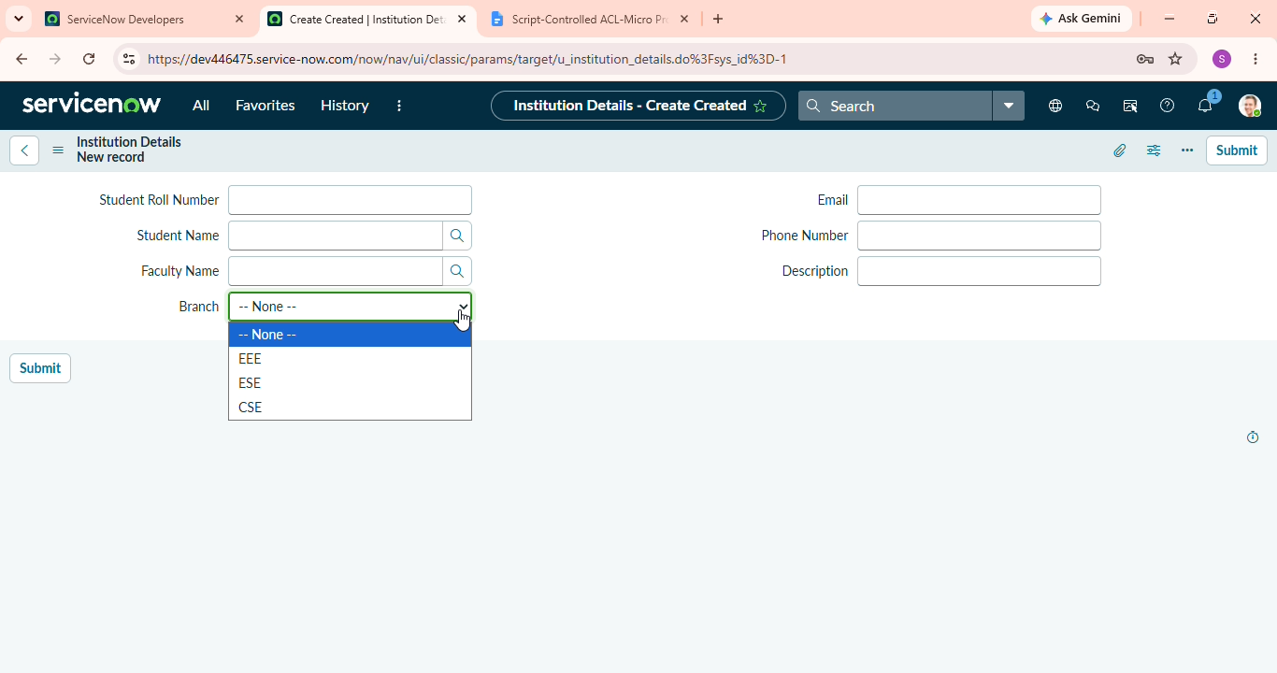
5. Record Creation
Multiple records were created with different branch values including:
- ECE
- EEE
- CSE
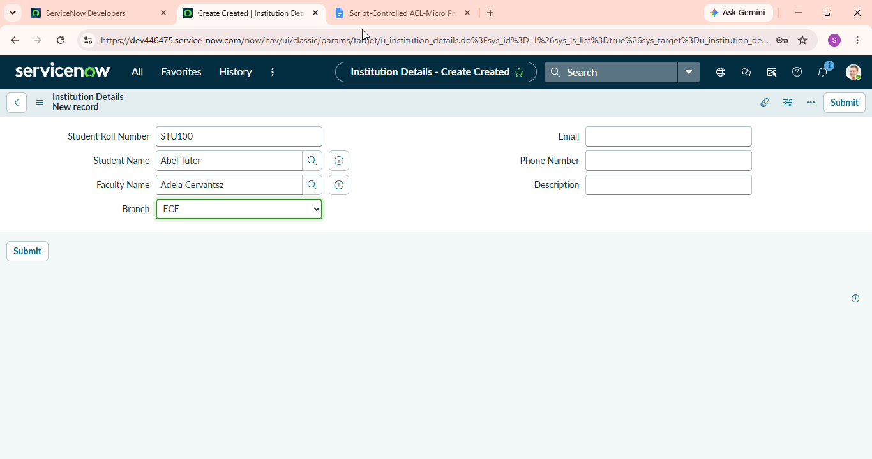
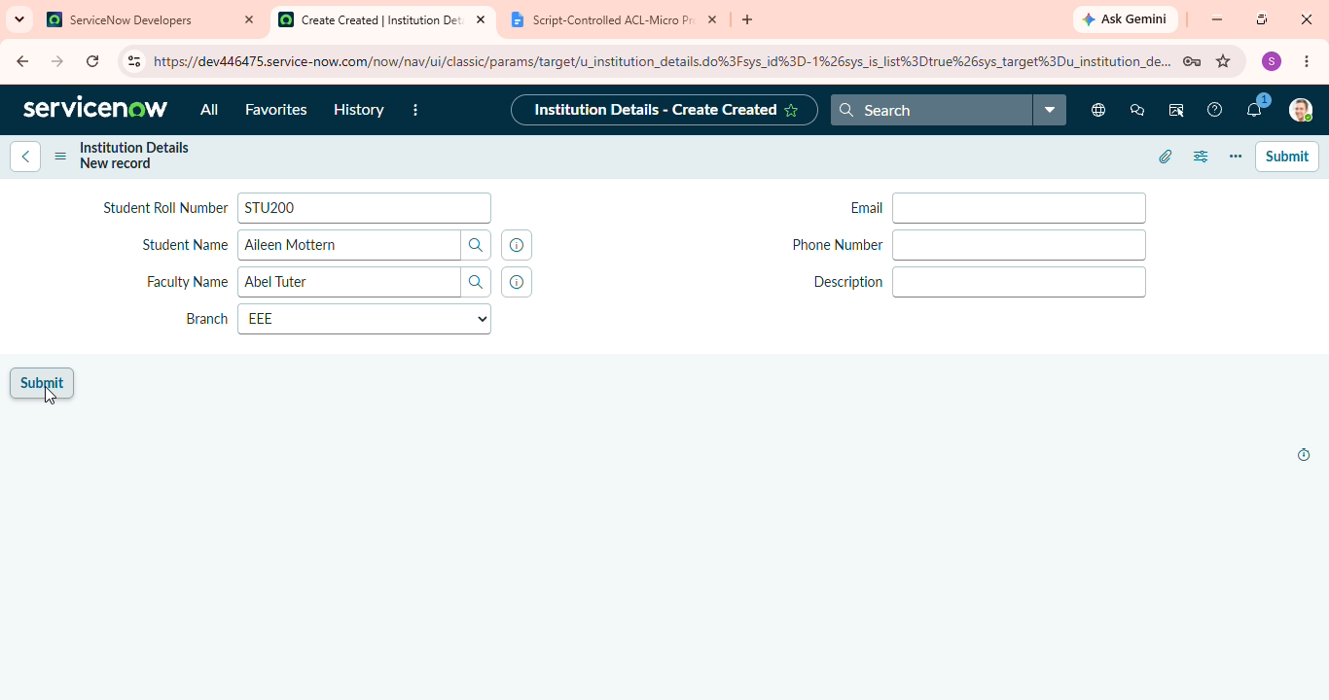
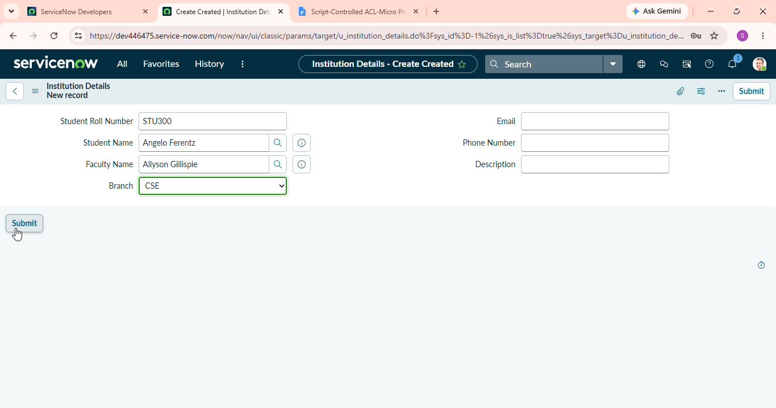
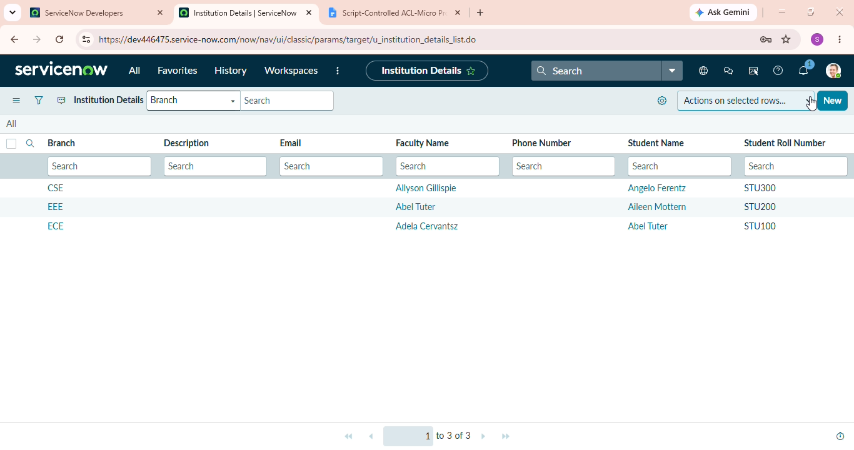

6. READ ACL Development
The READ ACL was configured with:
Type: record
Operation: read
Name: u_institution_details
Active: true
Advanced: true
Requires role: bb1
Data condition: Branch is EEE
Script
(function () {
// Allow admin users full access
if (gs.hasRole('admin')) {
return true;
}

// Allow only EEE branch users to see EEE records
if (gs.hasRole('bb1')){
return true;
}

// Deny access for all others
return false;
})();
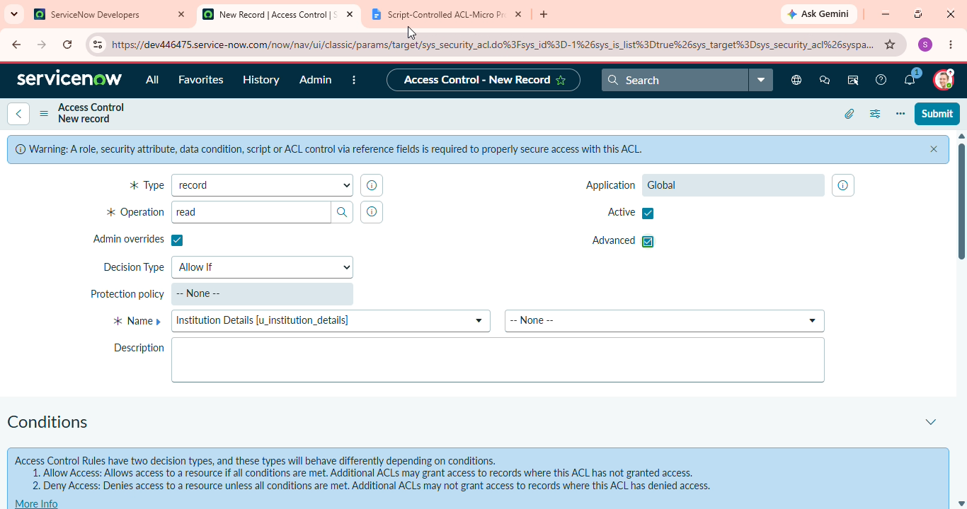
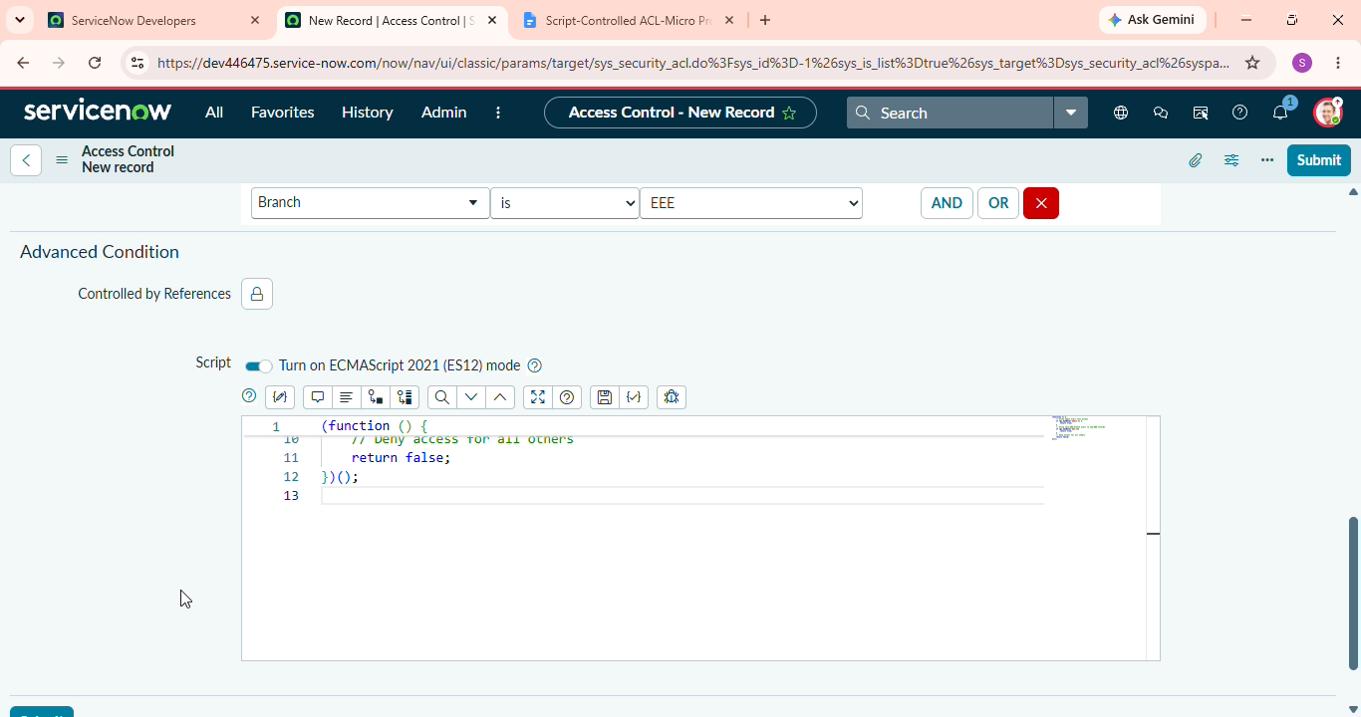
7. CREATE ACL Development
Type: record
Operation: create
Name: u_institution_details
Active: true
Requires role: bb2
No data condition is added.
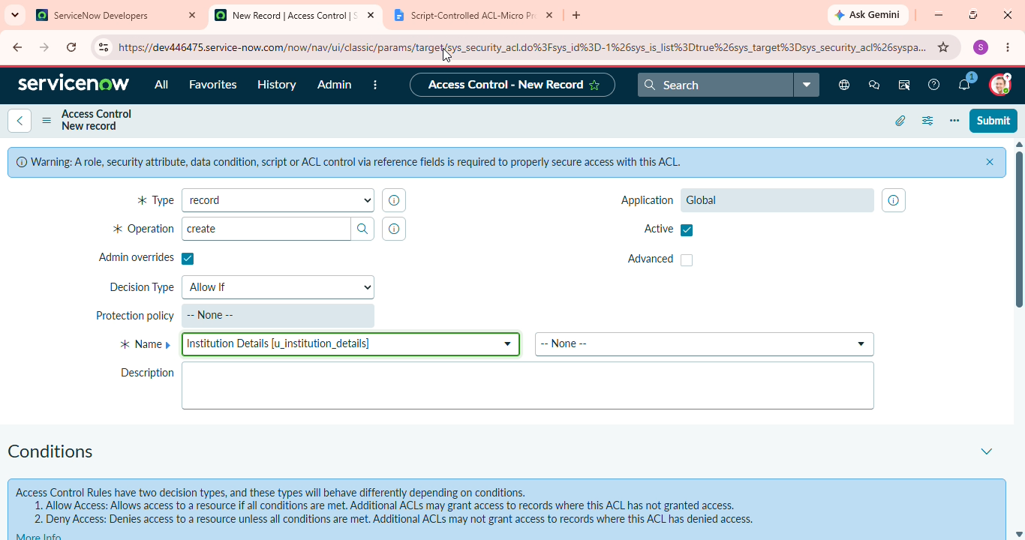
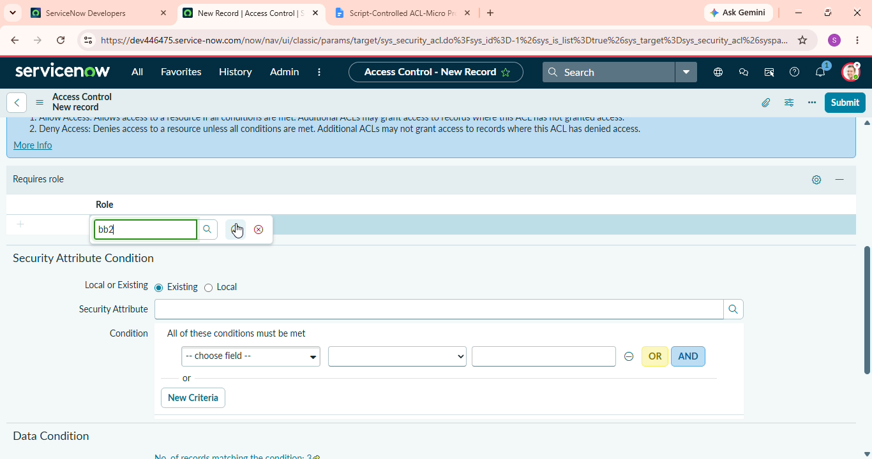
8. WRITE ACL Development
Type: record
Operation: Write
Name: u_institution_details
Active: true
Requires role: bb3
No data condition is added.
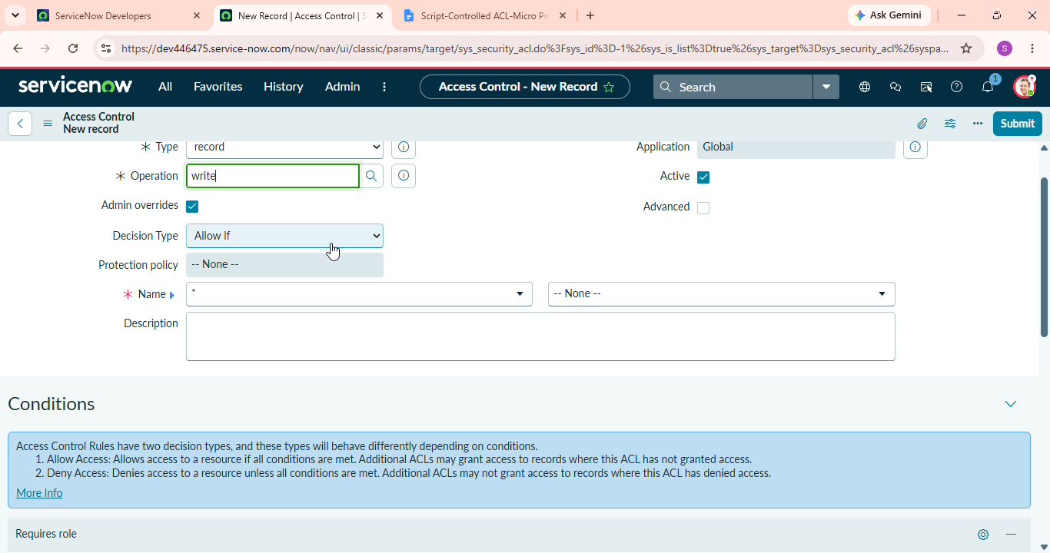
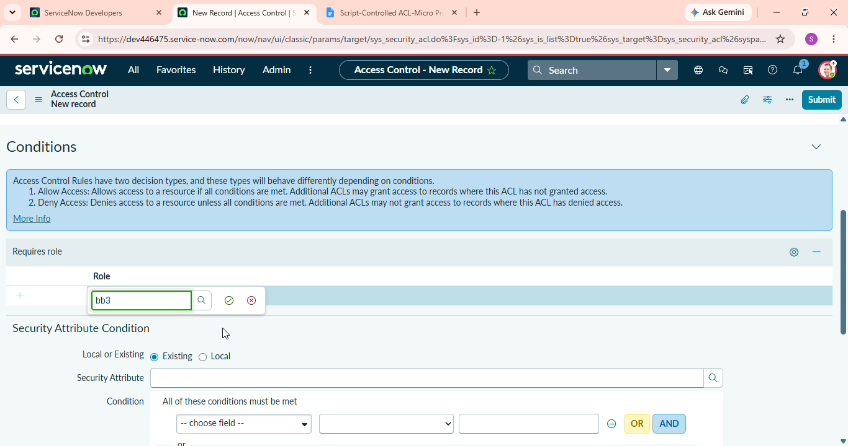
9. DELETE ACL Development
Type: record
Operation: Delete
Name: u_institution_details
Active: true
Requires role: bb4
No data condition is added.
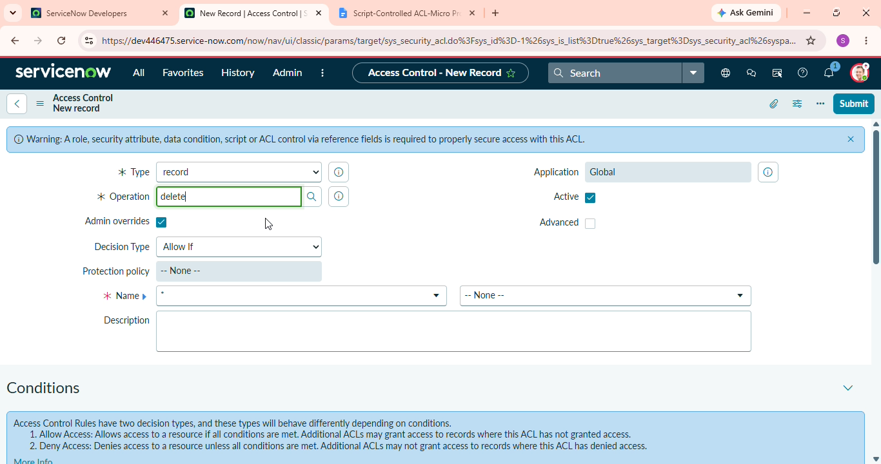
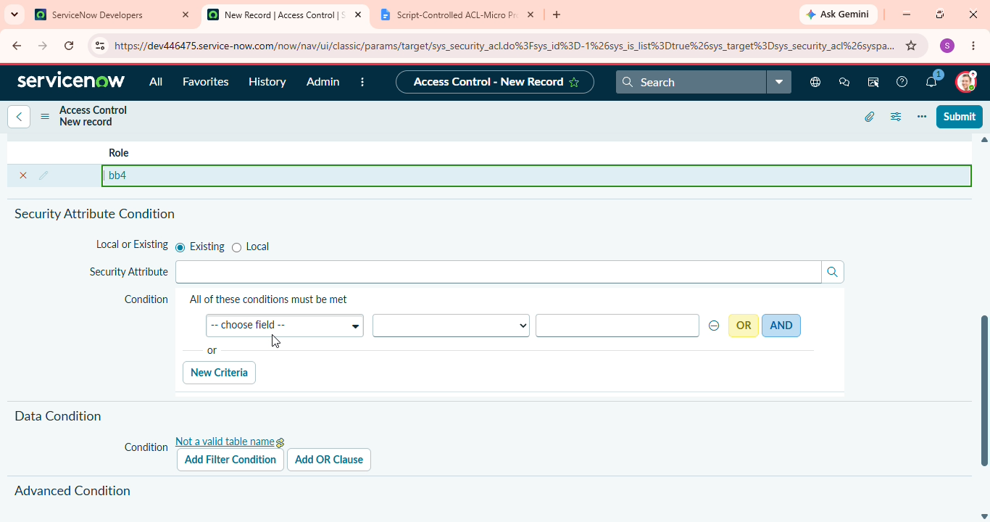
10. Development Evidence
The following screenshots should be added to this phase folder:
- User creation
- Role creation
- Table creation
- Field creation
- Record creation
- READ ACL
- READ ACL script
- CREATE ACL
- WRITE ACL
- DELETE ACL

